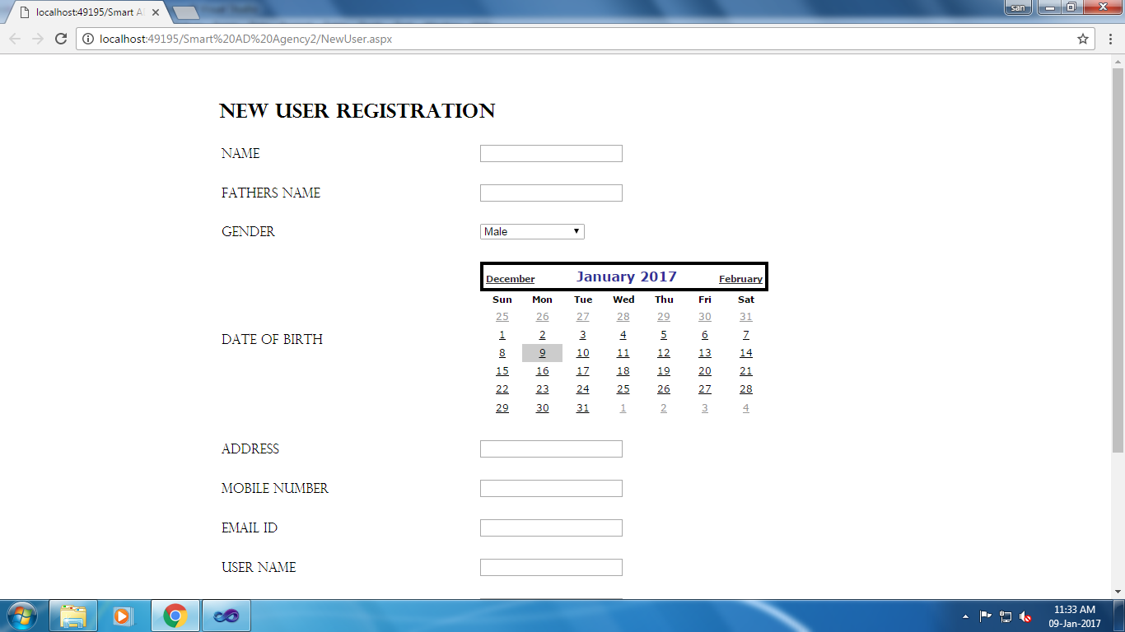

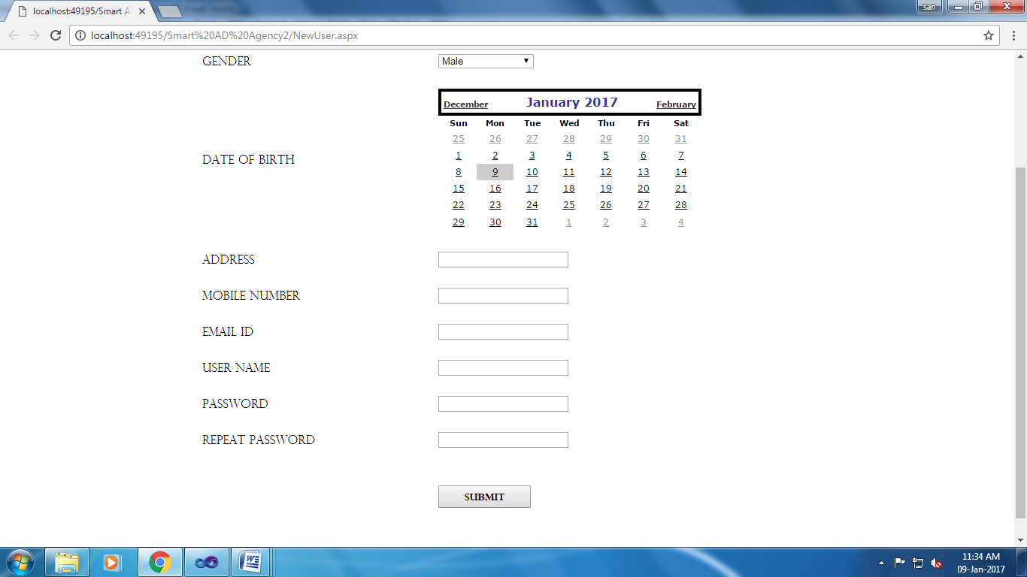

using System;

using System.Collections.Generic;

using System.Linq;

using System.Web;

using System.Web.UI;

using System.Web.UI.WebControls;

using System.Data.SqlClient;

public partial class NewUser : System.Web.UI.Page

{

SqlConnection con = new SqlConnection(@"Data Source=.\SQLEXPRESS;AttachDbFilename=C:\Users\GOD\Desktop\sangeeth 2016\Smart AD Agency2\App_Data\Smart.mdf;Integrated Security=True;User Instance=True");

SqlCommand cmd;

protected void Page_Load(object sender, EventArgs e)

{

}

protected void Button1_Click(object sender, EventArgs e)

{

cmd = new SqlCommand("insert into Regtb values('" + TextBox1.Text + "','" + TextBox2.Text + "','" +DropDownList1 .Text + "','"+Calendar1 .VisibleDate+ "','" + TextBox3.Text + "','" + TextBox4.Text + "','" + TextBox5.Text + "','" + TextBox6.Text + "','" + TextBox7.Text + "','" + TextBox8.Text + "')", con);

con.Open();

cmd.ExecuteNonQuery();

con.Close();

Response.Write("<script language=javascript>alert('Register Successfully!')</script>");

Response.Redirect("UserLogin.aspx");

}

}

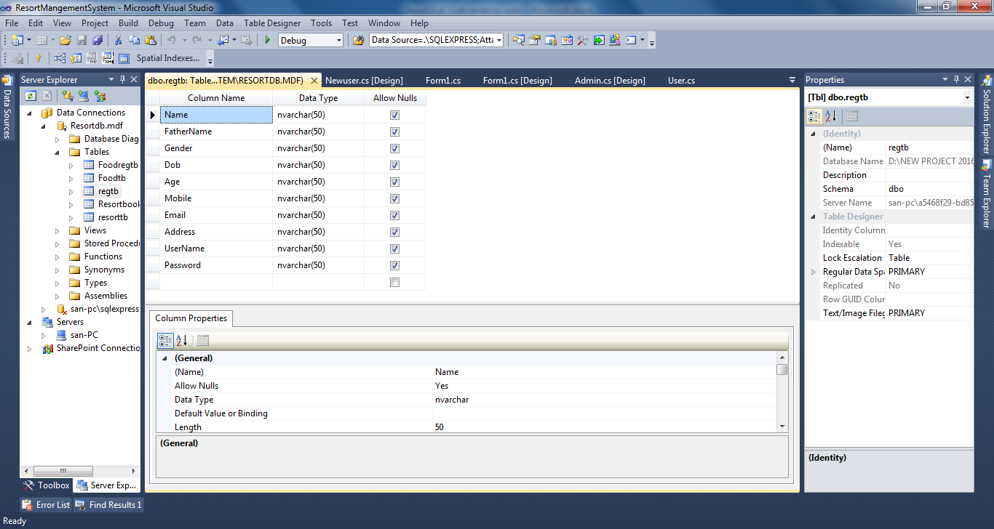

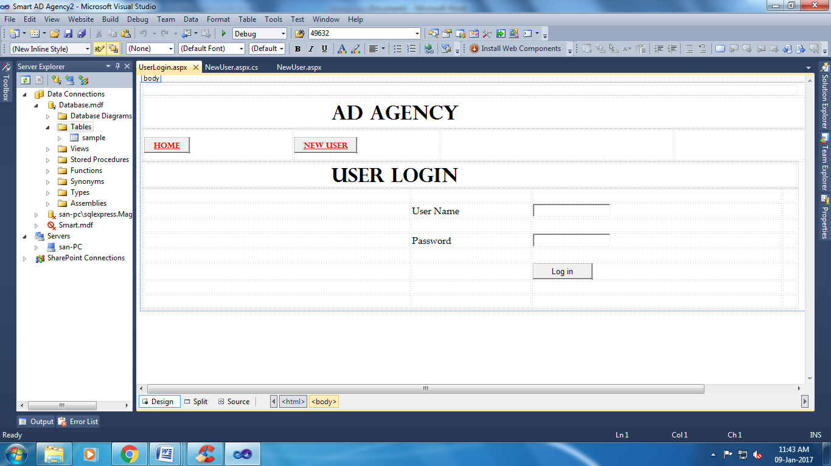

using System;

using System.Collections.Generic;

using System.Linq;

using System.Web;

using System.Web.UI;

using System.Web.UI.WebControls;

using System.Data.SqlClient;

public partial class UserLogin : System.Web.UI.Page

{

SqlConnection con = new SqlConnection(@"Data Source=.\SQLEXPRESS;AttachDbFilename=C:\Users\GOD\Desktop\sangeeth 2016\Smart AD Agency2\App_Data\Smart.mdf;Integrated Security=True;User Instance=True");

SqlCommand cmd;

protected void Page_Load(object sender, EventArgs e)

{

}

protected void Button3_Click(object sender, EventArgs e)

{

Response.Redirect("NewUser.aspx");

}

protected void Button4_Click(object sender, EventArgs e)

{

con.Open();

cmd = new SqlCommand("select * from Regtb where Username='" + TextBox1.Text + "' and Password='" + TextBox2.Text + "'", con);

SqlDataReader dr;

dr = cmd.ExecuteReader();

if (dr.Read())

{

Response.Redirect("AdDetails.aspx");

}

else

{

Response.Write("<Script> alert('Password Mismatch!') </Script>");

}

con.Close();

}

protected void Button1_Click(object sender, EventArgs e)

{

Response.Redirect("AdminLogin.aspx");

}

}